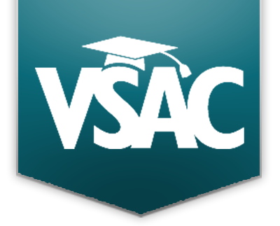
Vermont Career Connect Q&A Panels & Panelists, hosted by VSAC:

Government and Public Administration with Erik Wells (Williston Town Manager) and Charlie Gliserman (Public Engagement Director with Vermont Early Childhood Advocacy Alliance)
Health Science with Charlotte Smith (RN, Director of Training); David Saikin (Lead Technologist, Blood Bank at Littleton Regional Healthcare); Christine Cooley (Water Resources Program Manager at Tacoma-Pierce County Health Department); and Amber Gregory (Registered Yoga Teacher)
Hospitality and Tourism with Abby Crossen (Event Planner)
Human Services with Shannon Dufour-Martinez (Intensive Community Support Worker and Respite Provider); Elizabeth Kiker (Development Director at the House of Ruth); and Martha Dallas (Life-Cycle Celebrant)
IT Information Technology with Dan Bowles (Senior Software Engineer at Alley); Jo Telensky (IT & Network Administrator at Vermont Legal Aid and Legal Services Vermont); and Forrest Wallace (Software Engineer at Faraday)
Law, Public Safety, Corrections and Security with Robyn Sweet, CRP (Paralegal at Cleary Shahi & Aicher, P.C.); Lisa Burton (Captain at Castine Fire Rescue Department); and Jeff Whipple (Game Warden at the VT Department of Fish & Wildlife)
Science, Technology, Engineering and Mathematics with Jamie Gravelin (Project Manager at BioTek Instruments); Anna Prescott (Evaluation and Research Analyst at VSAC); Katie Ferguson (Technical Writer at Tamarac | Envestnet); and Julian Leon (Energy Educator)
Science, Technology, Engineering and Mathematics with Leah Milcarek (Senior Program Manager at Con Edison Solutions) and Todd Menees (River Management Engineer at the VT Department of Environmental Conservation)

